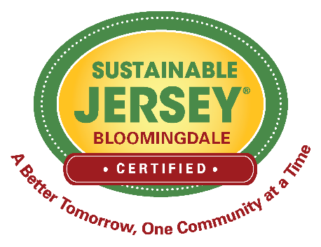
RESOLUTION NO. 2025-1.__
OF THE GOVERNING BODY OF
THE BOROUGH OF BLOOMINGDALE

REINSTATING BLOOMINGDALE’S GREEN TEAM ADVISORY COMMITTEE

WHEREAS, Bloomingdale has achieved Sustainable New Jersey bronze certification; and

WHEREAS, the Green Team Advisory Committee will continue to work towards recertification; and

NOW, THEREFORE, BE IT RESOLVED that to focus attention and effort within the Borough of Bloomingdale on matters of sustainability the Borough Council wishes to pursue local initiatives and actions that will lead to Sustainable New Jersey Municipal Certification by reinstating a Green Team Advisory Committee.

BE IT FURTHER RESOLVED by the Borough Council of the Borough of Bloomingdale that we do hereby authorize the following members to serve on the Green Team Advisory Committee for 2025:

Jennifer Altfield
Karen Schmidt
Mike Mascitello
Patrick Cecala
Robert Fry
Carol Jagiello
Mark Crum
Karin LaGreca
Mayor John D’Amato
Councilmember, Dawn Hudson
Councilmember, Dominic Catalano
Business Administrator, Mike Sondermeyer

