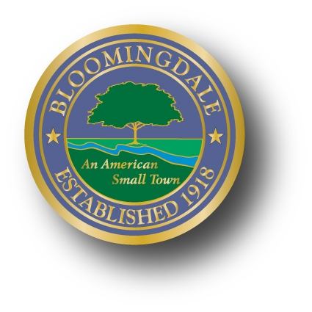
PROCLAMATION

WHEREAS, Paul Raymond Nelson will celebrate his one hundredth birthday on May 31, 2016; and

WHEREAS, Paul had been a resident of the Borough of Bloomingdale; and

WHEREAS, throughout his 100 years, Paul was a sprint and broad jump champion in the Los Angeles Junior Olympics, was a Physicist for Hanford Atomic Works and later on the Atomic Energy Commission; and

WHEREAS, Paul has been blessed with two daughters and on May 14, 2016 will celebrate 72 years of marriage to his wife Helen Lucena; and

WHEREAS, Paul has been witness to innumerable historical events, and changes in the Borough;

NOW, THEREFORE, BE IT RESOLVED, the Mayor and Council of the Borough of Bloomingdale wish to recognize Paul’s efforts and achievements; and

BE IT PROCLAIMED, by the Mayor and Council of the Borough of Bloomingdale that May 31, 2016 is hereby declared Paul Raymond Nelson Day in the Borough of Bloomingdale.

_______________________________
Mayor Jonathan Dunleavy
Borough of Bloomingdale

