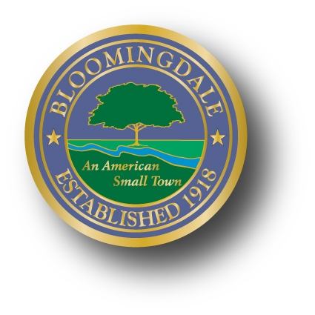
PROCLAMATION

WHEREAS, Kristen Toedtmann is a Bloomingdale resident and a student at Butler High School; and

WHEREAS, Kristen has been selected by “The Hester Schuyler Colfax Chapter” of the National Society of the Daughters of the American Revolution” for a Good Citizen Award; and

WHEREAS, Kristen has displayed outstanding academic achievements; patriotism and leadership;

NOW, THEREFORE, BE IT RESOLVED, the Mayor and Council of the Borough of Bloomingdale wish to recognize and congratulate Kristen’s efforts and achievements both for herself and her community; and

BE IT PROCLAIMED, by the Mayor and Council of the Borough of Bloomingdale that May 15, 2016 is hereby declared “Kristen Toedtmann Day” in the Borough of Bloomingdale.

_______________________________
Mayor Jonathan Dunleavy
Borough of Bloomingdale

