ORDINANCE ____-2016
OF THE GOVERNING BODY
OF THE BOROUGH OF BLOOMINGALE

AN ORDINANCE OF THE BOROUGH OF BLOOMINGDALE, IN THE COUNTY OF PASSAIC AND STATE OF NEW JERSEY, amending chapter 2, “administration,” article v, “departments established,” and chapter 17, “water,” section 17-2, “general regulations” of the Code of the Borough of Bloomingdale

WHEREAS, the Borough of Bloomingdale undertook to analyze the efficiency of Borough operations; and

WHEREAS, as a result of the efficiency study, the Borough determined that it would be beneficial to Borough operations for the Water & Sewer Department to be merged into the Department of Public Works; and

WHEREAS, the newly created Division of Municipal Utility Services shall operate under the authority of the Superintendent of Public Works.

BE IT ORDAINED, by the Borough Committee of the Borough of Bloomingdale, in the County of Passaic, and State of New Jersey, as follows:

SECTION 1. Chapter 2, “Administration,” Article V, “Departments Established,” Section 2-33, “Department of Municipal Utility Services,” of the Code of the Borough of Bloomingdale is hereby removed in its entirety and shall be designated as “Reserved.”

SECTION 2. Chapter 2, “Administration,” Article V, “Departments Established,” Section 2-34, “Department of Public Works,” of the Code of the Borough of Bloomingdale is hereby amended to read in its entirety as follows:

2-34 DEPARTMENT OF PUBLIC WORKS.

2-34.1 Creation; Divisions; Organization.
A Department of Public Works is hereby created which is to have five (5) divisions as follows:

(1) The Division of Sanitation and Recycling;
(2) The Division of Public Buildings and Grounds;
(3) The Division of Roads;
(4) The Division of Automotive and Equipment Maintenance; and
(5) The Division of Municipal Utility Services.

The Department of Public Works shall be organized as follows:
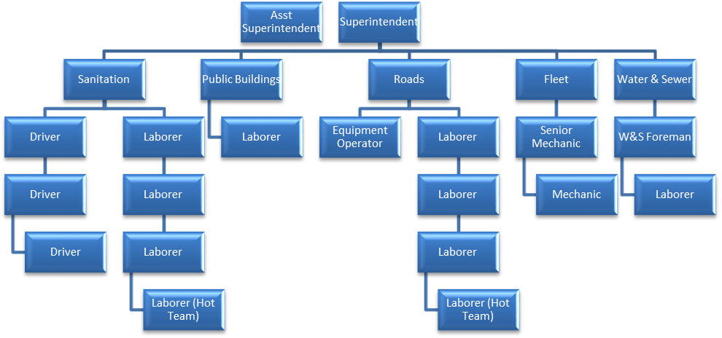

2-34.2 Superintendent of Public Works; Powers and Duties.
The position of Superintendent of Public Works is hereby created. The Superintendent shall be responsible:
a. To the Council for the general policies and procedures of the Department.
b. To the Borough Administrator for the overall administration of the Department.
c. For project planning and control.
d. For processing purchasing beyond requisitioning and keeping all the records of same according to the voucher-encumbrance system in effect.
e. For handling matters, including all citizen complaints, involving citizen-owned property and for the prompt response to same to the satisfaction of the citizen and the Borough administration, whenever possible.
f. As Equipment Manager of the Borough, for the prompt repair and maintenance of all vehicles and equipment according to a comprehensive preventive maintenance program.
g. For special studies to promote the efficiency and effectiveness of the Department.
h. For developing, implementing and updating a safety program for the Borough and for compliance of the Department of Public Works with all State Statutes and regulations pertaining to the functions of the Department of Public Works.
i. For developing, in conjunction with the offices of the Borough Administrator, annual, three (3) and five (5) year programs for public works and Borough property and equipment, including drainage improvement and road maintenance and vehicles, as input to the capital budget.
j. For preparing the Department budgets.

k. For supervising all the daily operations in the Division of Sanitation and Recycling; the Division of Public Buildings and Grounds; the Division of Roads; the Division of Automotive and Equipment Maintenance; and the Division of Municipal Utility Services.

l. For assigning the appropriate personnel to the daily tasks.

m. For supervising the employees assigned to the Department of Public Works in their assigned tasks.

n. For maintaining accurate time logs for all the assigned employees.

o. For verifying all the requested purchase vouchers.

p. For performing or assigning all administrative functions.

2-34.3 Assistant Superintendent of Public Works; Powers and Duties.
The position of Assistant Superintendent of Public Works is hereby created. The Assistant Superintendent shall assist the Superintendent in the performance of the Superintendent's duties as set forth in subsection 2-34.2 in the manner as may be directed by the Superintendent. In addition, the Assistant Superintendent shall perform all the duties of the Superintendent in the absence or inability of the Superintendent to perform such duties.

2-34.4 Supervision of Employees.
Employees of the Department of Public Works shall be under the direct supervision of the Superintendent of Public Works.

2-34.5 Assigning of Employees and Equipment.
The Superintendent shall have the authority to assign employees and equipment among the various divisions of the Department.

2-34.6 Responsibilities of Division of Public Buildings and Grounds.

The Division of Public Buildings and Grounds shall be responsible for maintenance of all Borough-owned buildings, all Borough-owned parks, and any other public property.

2-34.7 Responsibilities of Division of Roads.
The Division of Roads shall be responsible for maintenance and construction of all municipally-accepted streets and roads; maintenance and construction of the municipal storm drain system; and planning and implementation of snow removal and sanding operations.

2-34.8 Responsibilities of the Division of Sanitation and Recycling.
If the Borough has undertaken to collect refuse and recycling, the Division of Sanitation and Recycling shall be responsible for such collection within the Borough limits and its deposit at the disposal sites designated by the Borough.

2-34.9 Responsibilities of Division of Automotive and Equipment Maintenance.
The Division of Automotive and Equipment Maintenance is responsible for the maintenance of all Borough-owned vehicles and equipment.

2-34.10 Responsibilities of the Division of Municipal Utility Services.

The Division of Municipal Utility Services is responsible for the operation and maintenance of the water supply system and the sanitary sewer disposal system. The Division of Municipal Utility Services shall operate in accordance with, and be governed by, any all provisions comprising Chapters XVII, Water, and XVIII, Sewer, of the Revised General Ordinances of the Borough of Bloomingdale, and any and all applicable rules and regulations heretofore duly enacted by the Borough of Bloomingdale.

2-34.11 General Foreman of the Department of Public Works.
a. Position Created. The position of General Foreman of the Department of Public Works is hereby created.
b. Appointment; Compensation. Pursuant to N.J.S.A. 40A:9-154 et seq., a General Foreman shall be appointed by the Mayor with the advice and consent of the Council. His or her compensation shall be fixed in the Salary Ordinance.
c. Powers and Duties. The duties of the General Foreman shall be any Department of Public Works duties as assigned by the Superintendent or Assistant Superintendent of Public Works. The General Foreman shall report any problems to the Superintendent.

SECTION 3. Chapter 17, “Water,” Section 17-2, “General Regulations,” Section 17-2.1, “Creation of Water Department; Superintendent of Municipal Utility Services Appointed,” of the Code of the Borough of Bloomingdale is hereby amended to read in its entirety as follows:

17-2.1 Creation of Division of Municipal Utility Services; Superintendent of Municipal Utility Services Appointed.
a. The Division of Municipal Utility Services of the Borough of Bloomingdale is hereby created as a division of the Department of Public Works.
b. The Superintendent of Public Works (the "Superintendent" here-in) shall be the chief executive officer of the Department. He shall be in charge of the day-to-day administration of the Department and shall be responsible for the efficient operation thereof in accordance with the provisions of this chapter.

c. The Borough shall be authorized to enter into contracts with independent contractors to perform services necessary in connection with the operation of the Division of Municipal Utility Services. The services to be performed shall be in accordance with the provisions of such contracts as are approved by the Governing Body.

SECTION 4. All ordinances or parts of ordinances of the Borough of Bloomingdale inconsistent herewith are repealed to the extent of such inconsistency.

SECTION 5. If any section, subsection, clause or phrase of this ordinance is for any reason held to be unconstitutional or invalid by any court or competent jurisdiction, such decision shall not affect the remaining portion of this ordinance.

SECTION 6. This law shall take effect immediately upon final passage, approval and publication as required by law.

BOROUGH OF BLOOMINGDALE
COUNTY OF PASSAIC
ATTEST: STATE OF NEW JERSEY

_____________________________ By: _____________________________
Jane McCarthy, Clerk Jonathan Dunleavy, Mayor

