Borough of Bloomingdale
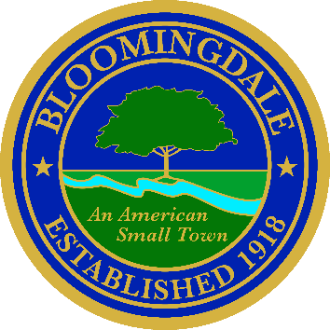
Office of: phone: (973) 838-0778 x-239
BREEANNA SMITH, RMC/CMR fax (973) 838-5115
MUNICIPAL CLERK bsmith@bloomingdalenj.net

Municipal office
101 Hamburg Turnpike
bloomingdale, new jersey 07403

LEGAL NOTICE

BOROUGH OF BLOOMINGDALE

PASSAIC COUNTY, NEW JERSEY

NOTICE OF PUBLIC HEARING

PLEASE TAKE NOTICE that the Mayor and Council of the Borough of Bloomingdale shall hold a PUBLIC HEARING on March 17, 2026 at 7:00P.M. in the Council Chambers of the Municipal Building located at 101 Hamburg Turnpike, Bloomingdale, NJ for the purpose of obtaining public comment relative to and taking formal action with respect to the Passaic County Historic Preservation Grant Program application in the amount of $100,000.00 for the following proposed project:

Bloomingdale Museum Renovations
The proposed project is to renovate the former firehouse garage into additional museum space at 52 Ballston Street.

Please feel free to attend the informational session scheduled as follows:

DATE: Tuesday, March 17, 2026
TIME: 7:00 P.M.
LOCATION: Council Chambers
Municipal Building
101 Hamburg Turnpike
Bloomingdale, NJ 07403

Breeanna Smith, RMC
Bloomingdale Municipal Clerk

