F. O’Reilly
BECAgenda4December2019

BLOOMINGDALE ENVIRONMENTAL COMMISSION

Agenda of December 4, 2019

MEMBERS
Carol Jagiello Jen Altfield
Mark Crum Frank O’Reilly Chairperson
Karen Labazetta
Mike Mascitello
Patrick Cecala

Location: Council Chambers
Time: 7:30 PM

Call to Order

Attendance

Acceptance of Minutes of October 2, 2019

Correspondence
Questions on the insert in tax bill that mentions “Appoint a Redeveloper to build our affordable housing….”
Meeting date for 20209

Bills

Early Public Discussion

Reports
Federal Hill
Highlands RMP
ANJEC
COAH
Friendship Park
-Where do we get a GPS coordinates
Oakwood Lake
-Poison Ivy
Sloan Park
-Completion date?
-Ceremony?
Dragonfly Meadows
Higgens Paragallo
Bi-Coastal Property
Forest Stewardship
Passaic County Greenway
North Bergen Power Plant
- Governor Murphy has expressed his opposition to the power plant
- https://www.northjersey.com/story/news/new-jersey/2019/10/09/nj-governor-phil-murphy-opposes-north-bergen-meadowlands-power-plant/3926364002/
Bloomingdale Centric
-Sloan Park Opening
-Cut over to Butler water
-Tastefully British Buildout plan and schedule

New Business
Political signs displayed on residences – Mark Redfield is investigating

Old Business
Removing water from the Pequannock River
-No Borough Ordinance regarding this
-Email sent to the State DEP asking if this is permissible
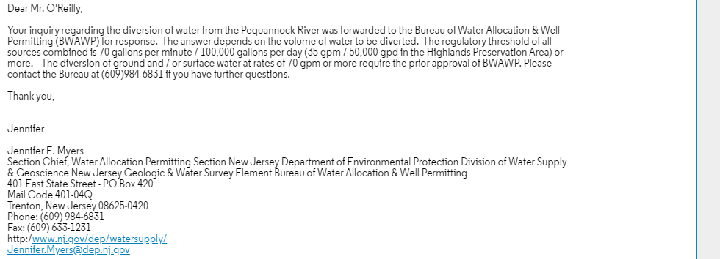

Late Public Discussion

Agenda Items for Next Month

Adjournment

