Borough of Bloomingdale
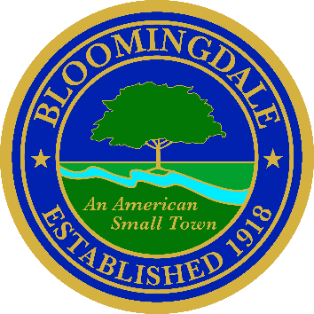
Office of: phone: (973) 838-0778 x-239
BREEANNA SMITH, RMC/CMR fax (973) 838-5115
MUNICIPAL CLERK bsmith@bloomingdalenj.net

Municipal office
101 Hamburg Turnpike
bloomingdale, new jersey 07403

LEGAL NOTICE

BOROUGH OF BLOOMINGDALE
2026 ANNUAL MEETING NOTICE
FOR THE MAYOR & COUNCIL

PLEASE TAKE NOTICE, that in accordance with the Open Public Meetings Act, N.J.S.A. 10:4-6 et seq., the meetings of the Borough Council of the Borough of Bloomingdale shall be as follows for the 2026 calendar year:

REGULAR COUNCIL MEETINGS
January 6, 2026 (Reorganization Meeting)
January 20, 2026
February 3, 2026
February 17, 2026
March 3, 2026
March 17, 2026
April 7, 2026
April 21, 2026
May 5, 2026
May 19, 2026
June 9, 2026
June 23, 2026
July 21, 2026
August 18, 2026
September 1, 2026
September 15, 2026
October 6, 2026
October 20, 2026
November 10, 2026
November 24, 2026
December 15, 2026

BE IT FURTHER NOTED that all Regular Meetings of the Governing Body of the Borough of Bloomingdale as outlined herein shall be held in the council chambers of Borough Hall located at 101 Hamburg Turnpike, Bloomingdale, NJ and all such meetings shall begin at 7:00 p.m.

Official Action May be Taken

Breeanna Smith, R.M.C.
Municipal Clerk

Published in the Herald News 1/9/2026
Posted on Borough Website
Transmitted to Record, Trends & Star-Ledger; publication not requested

