SEPTEMBER 20TH IS PASSPORT DAY IN PASSAIC COUNTY
Planning to travel outside of the United States?


First, plan to get your passport!
Kristin M. Corrado, Esq., Passaic County Clerk, and her staff will be hosting a special passport event in honor of National Passport Awareness Month. A passport photo will be provided for free with payment of all application fees as part of this outreach event.
Date: Saturday, September 20, 2014
Time: 9:00 a.m. until 12:00 noon
Place: Passaic County Clerk’s Office
401 Grand Street, Room 130
Paterson, New Jersey 07505
AND
Passaic County Clerk’s Satellite Office
1237 Ringwood Avenue
Haskell (Wanaque), New Jersey 07420
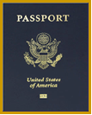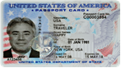
For information on fees and any other questions, please call the County Clerk’s office at (973)225-3690 or visit our website at www.passaiccountynj.org.

