Borough of Bloomingdale
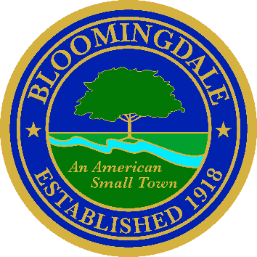
Office of: phone: (973) 838-0778 x-239
BREEANNA SMITH, RMC/CMR fax (973) 838-5115
MUNICIPAL CLERK bsmith@bloomingdalenj.net

Municipal office
101 Hamburg Turnpike
bloomingdale, new jersey 07403

LEGAL NOTICE

BOROUGH OF BLOOMINGDALE

PASSAIC COUNTY, NEW JERSEY

ROSE FUND ADVISORY BOARD

In accordance with the Open Public Meetings Act, PLEASE TAKE NOTICE that the ROSE Fund Advisory Board meetings will be held on the following dates in the Council Chambers of the Municipal Building located at 101 Hamburg Turnpike, Bloomingdale NJ 07403 at 7:00PM.

Thursday, February 26, 2026

Official Action May Be Taken

Breeanna Smith, R.M.C.
Municipal Clerk

Transmitted to Herald News
Posted on Borough Website

