Borough of Bloomingdale
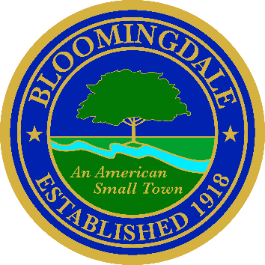
Office of: phone: (973) 838-0778 x-239
BREEANNA SMITH, RMC/CMR fax (973) 838-5115
MUNICIPAL CLERK bsmith@bloomingdalenj.net

Municipal office
101 Hamburg Turnpike
bloomingdale, new jersey 07403

Note to editor:
Please publish the following legal ad in the Herald News ASAP
Proof of publication is requested
no affidavit
Account #1185926

LEGAL NOTICE

BOROUGH OF BLOOMINGDALE

PASSAIC COUNTY, NEW JERSEY

NOTICE OF TIME CHANGE OF COUNCIL MEETING

IN ACCORDANCE WITH THE OPEN PUBLIC MEETINGS ACT, PLEASE TAKE NOTICE that the regularly scheduled time of the Borough of Bloomingdale Regular Council meeting to be held on Tuesday, February 17, 2026 has been changed from 7:00 p.m. to 6:30 p.m. The meeting will be held in the Council Chambers of the Bloomingdale Municipal Building, located at 101 Hamburg Turnpike, Bloomingdale, New Jersey.

Official Action May Be Taken

Breeanna Smith, R.M.C.
Municipal Clerk

Published in the Herald News
Posted on Borough Website

