Borough of Bloomingdale
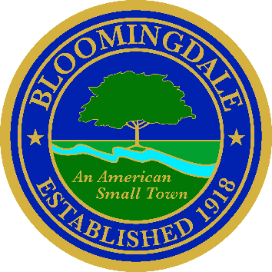
Office of: phone: (973) 838-0778 x-239
BREEANNA SMITH, RMC/CMR fax (973) 838-5115
MUNICIPAL CLERK bsmith@bloomingdalenj.net

Municipal office
101 Hamburg Turnpike
bloomingdale, new jersey 07403

LEGAL NOTICE

Note to editor:
Please publish the following legal ad in the Herald News on February 13, 2026 & February 27, 2026.
Proof of publication is requested
no affidavit
Account #1185926

BOROUGH OF BLOOMINGDALE

PASSAIC COUNTY, NEW JERSEY

TAKE NOTICE that pursuant to P.L. 2025, c. 72, the complete text of each legal notice of the Borough of Bloomingdale, County of Passaic including the Boards, Commissions and the like may be obtained or viewed by the public on our official Internet Website: https://www.bloomingdalenj.net/cn/webpage.cfm?tpid=19087 Once the Secretary of State has its website available, a hyperlink to same will be provided.
Breeanna Smith, R.M.C.
Municipal Clerk

Published in the Herald News & Borough Website

