Borough of Bloomingdale
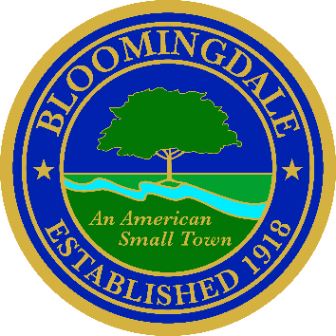
Office of: phone: (973) 838-0778 x-239
BREEANNA SMITH, RMC/CMR fax (973) 838-5115
MUNICIPAL CLERK bsmith@bloomingdalenj.net

Municipal office
101 Hamburg Turnpike
bloomingdale, new jersey 07403

LEGAL NOTICE

BOROUGH OF BLOOMINGDALE

PASSAIC COUNTY, NEW JERSEY
NOTICE OF FINAL ADOPTION
ORDINANCE NO. 1-2026
AN ORDINANCE ESTABLISHING A MINIMUM AND MAXIMUM RANGE OF SALARY AND COMPENSATION FOR CATEGORIES AND TITLES OF OFFICERS, NON-CONTRACTUAL EMPLOYEES AND CONTRACTUAL EMPLOYEES OF THE BOROUGH OF BLOOMINGDALE

Notice is hereby given that the above entitled ordinance was approved for adoption by the Governing Body of the Borough of Bloomingdale at an Official Meeting held on January 20, 2026 and approved by the Mayor.
Breeanna Smith, RMC
Municipal Clerk

Published in the Herald News
Posted on Borough Website

