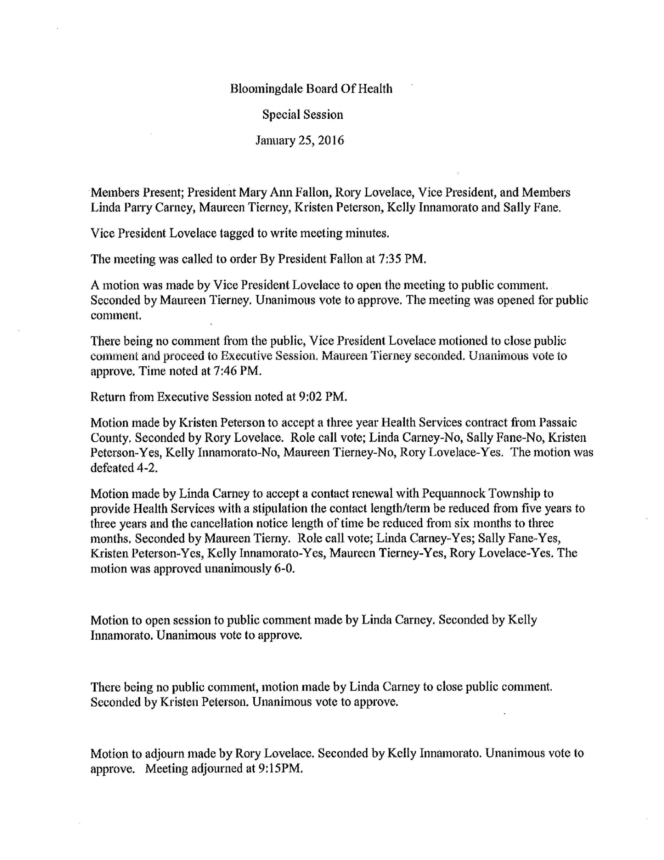
Approved : February 1, 2016
Peter Correale, Health Officer/Secretary

